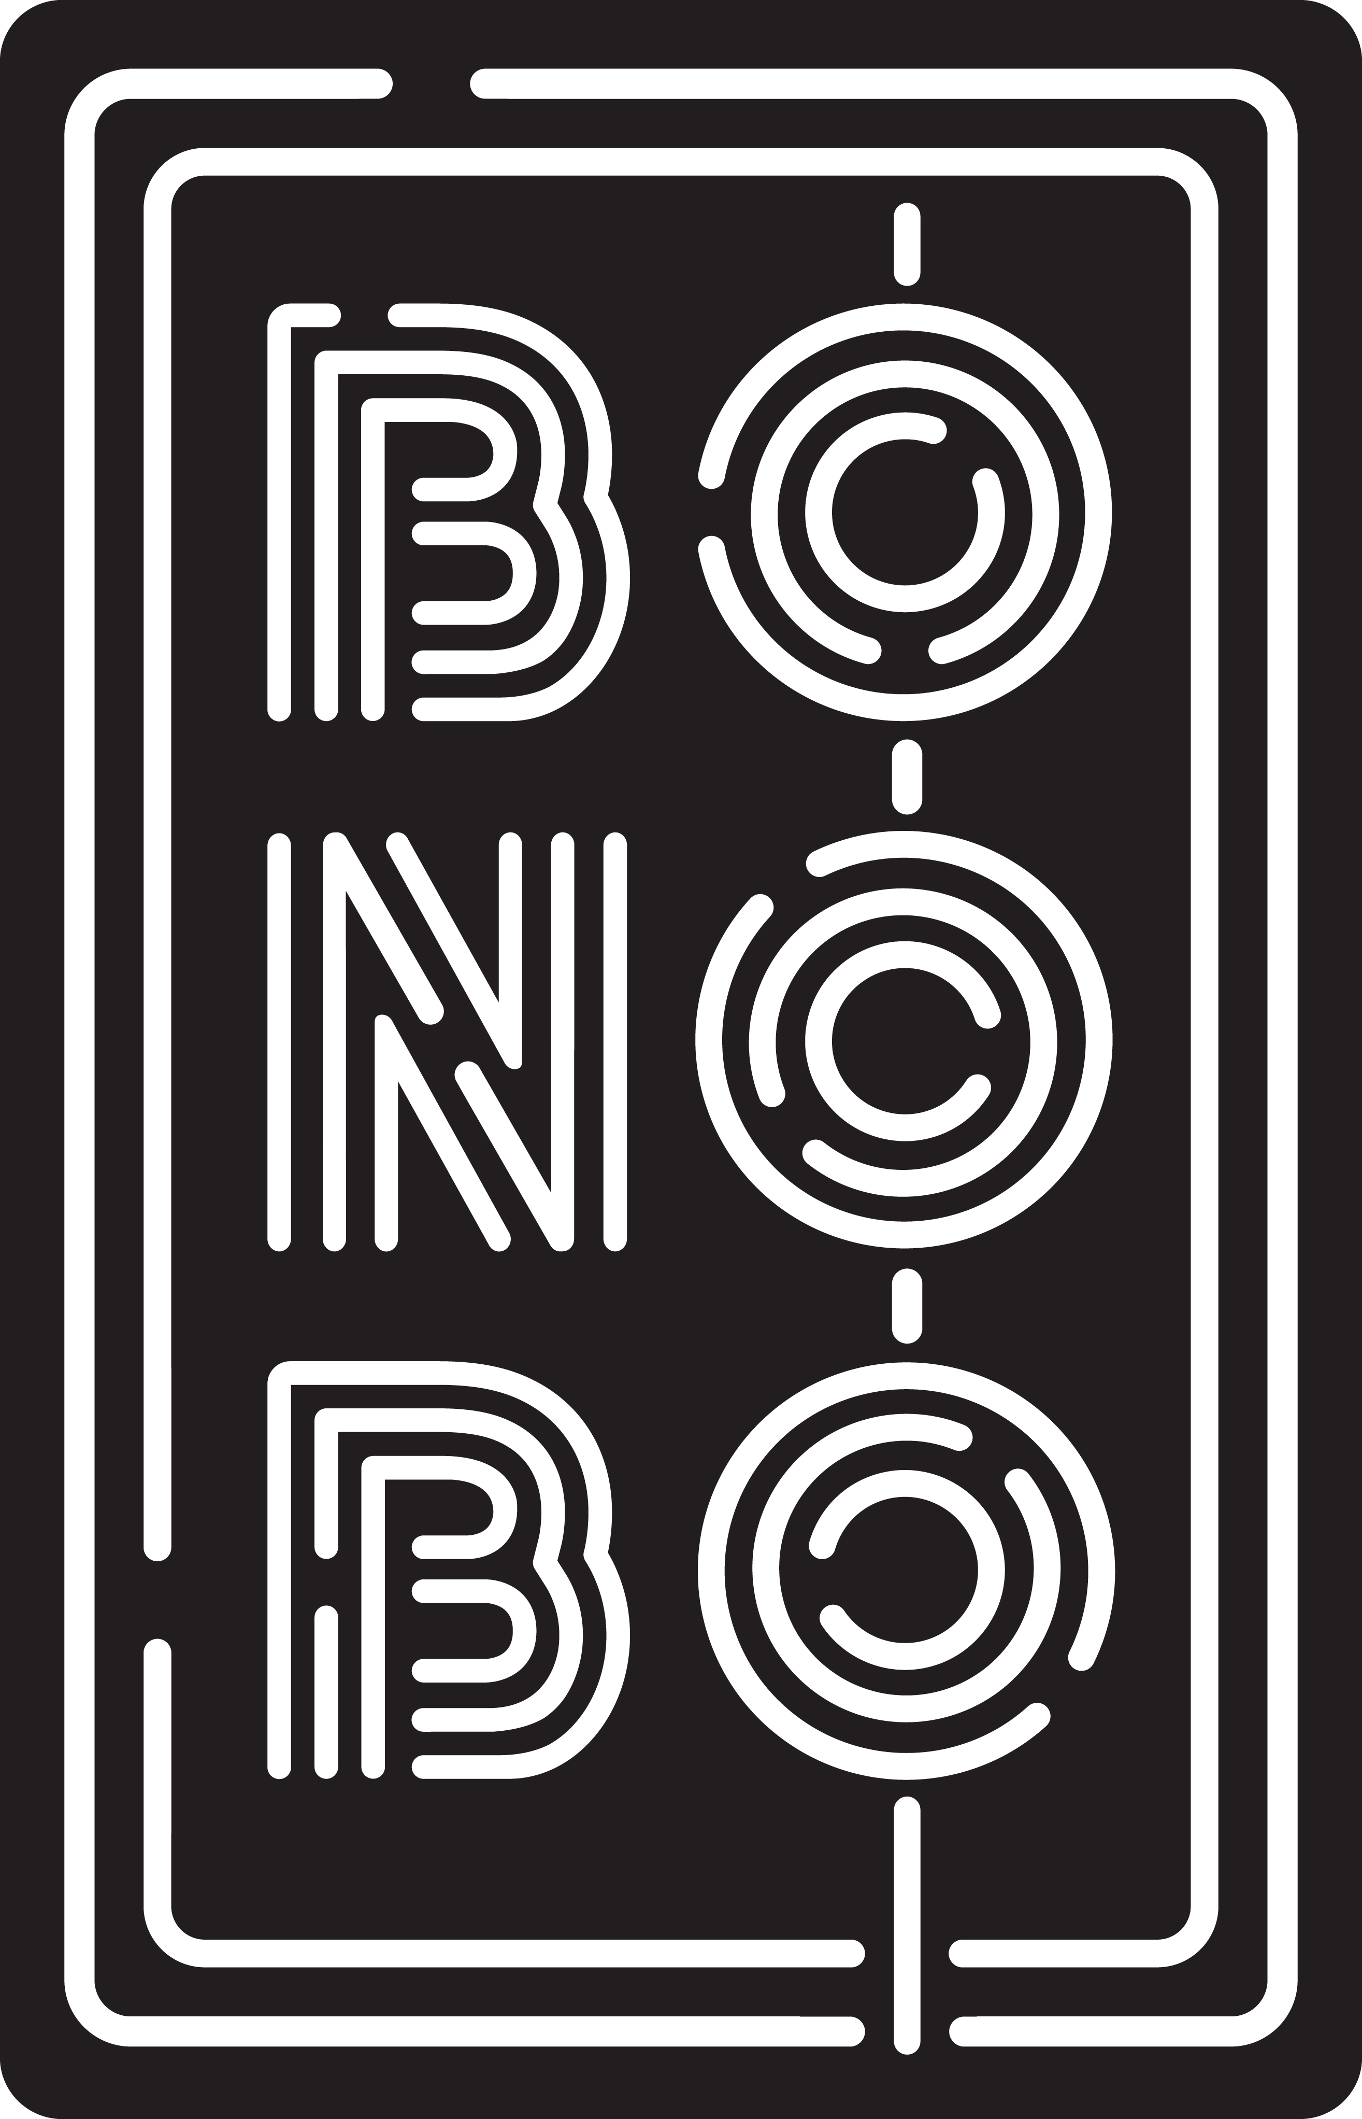

**Proposal Menu**

Beverage Deal: 20RMB on Asahi Draft Beer, 30RMB on House Wine, and Standard Pours, FREE French Fries

Dinner April 27, 2016.

100 Pax, 20% DC

Bar Snacks 小吃

Edamame Hummus wasabi peas, radish, crostini

豆酥 芥末豌豆, 樱桃萝卜, 香脆面包片 45

General Tso’s Cauliflower puffed rice, fortune cookie chips, pickled peppers 左将军香脆花菜 泡泡米, 饼干碎, 酸甜椒 38

Shichimi Spiced Pork Rinds garlic vinegar dipping sauce

酥脆猪皮 蒜泥香醋蘸酱 42

Golden Baos braised bacon, sunny quail egg, XO hollandaise

黄金台式刈包 五花肉, 鹌鹑蛋, XO荷兰酱 52

Monkey Wings crushed peanuts, cilantro

超级香脆鸡翅 秘制甜辣酱, 花生碎, 香菜 48

Asian Caesar Slaw sesame crunch, pickled daikon, miso ranch

卷心菜色拉 芝麻酥, 秘制萝卜, 味增香料奶油酱 48

Butter Lettuce Salad fines herbes, avocado, radish, wafu mignonette 奶油生菜色拉 混合香料, 牛油果, 萝卜, 和风木犀草 68

Kale Salad grains, broccoli, sunflower seeds, feta, ginger-carrot dressing 羽叶甘蓝色拉 杂粮, 西兰花, 葵花子, 飞达芝士, 生姜胡萝卜汁 68

ABC Wagyu Burger kimchi jam, sunny egg, american cheese ABC 双层和牛汉堡 泡菜酱, 单面黄, 美式芝士 88

Mac and Cheese 芝士焗通心粉 98